Sales Analysis Power BI Report :

1. **Introduction**

This document outlines the findings and insights derived from the completed Sales Analysis Power BI report. The report aims to provide a comprehensive overview of sales performance, identify trends and patterns, and uncover opportunities for improvement.

1. **Methodology**

The report leverages Microsoft Power BI for data visualisation and analysis. Data was sourced from [orders] and includes information on [List key data points included in the report, e.g., sales figures, products, customers, dates].

**3. Requirement Analysis**

The primary objective of the report is to:

* Analyse sales trends over time (daily, monthly, quarterly, and yearly).
* Identify top-selling products and categories.
* Evaluate customer buying behaviour and trends.
* Assess performance across different sales channels and regions.
* Gain insights into factors influencing sales performance.

**4. Other Parameters**

[Include any additional parameters specific to your analysis, such as:]

* Profit margins
* Customer demographics
* Marketing campaign effectiveness
* Inventory turnover

**5. Visualisations**

The Power BI report incorporates various charts and visuals to effectively communicate key findings. Here's a breakdown of the visualisations used:

* **Line Charts:** Track sales trends over time (daily, monthly, etc.).

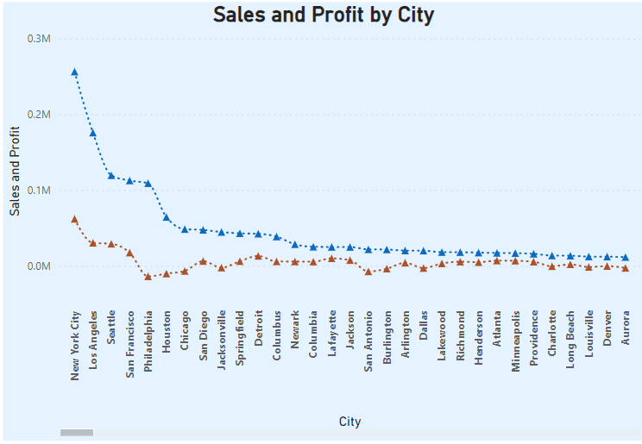

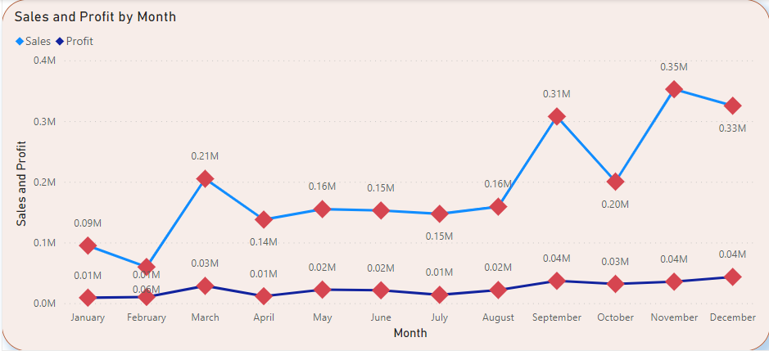

* **Bar Charts:** Compare sales performance across different product categories, regions, or sales channels.

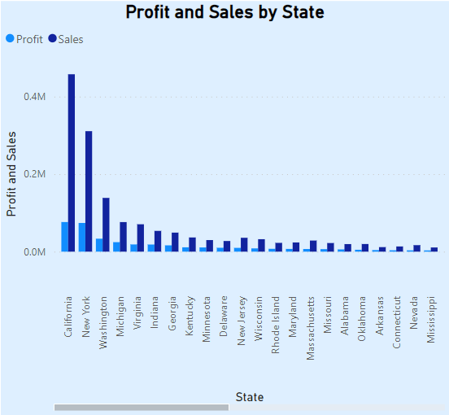

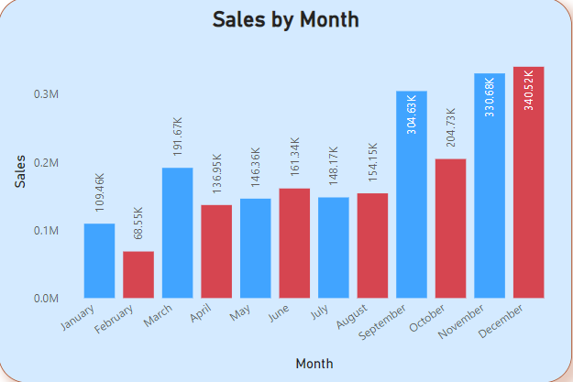

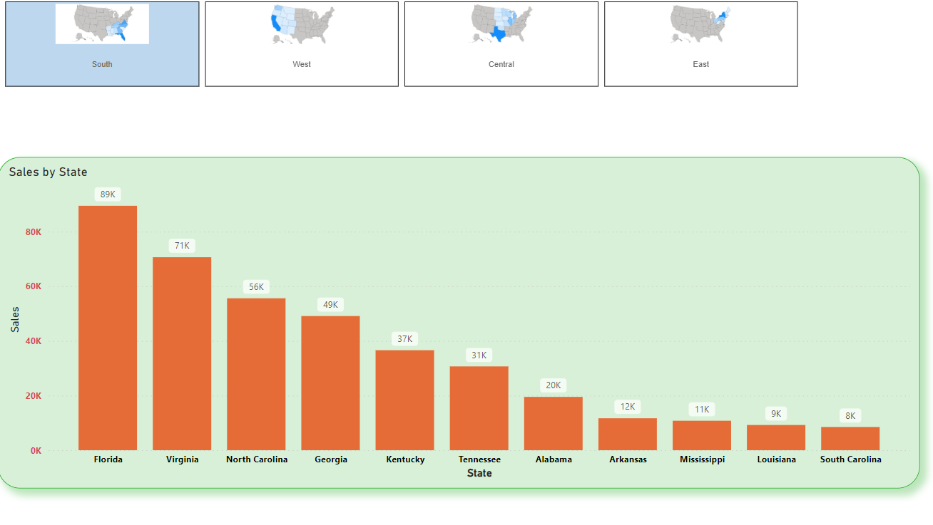

* **Pie Charts:** Illustrate the distribution of sales among various product categories or customer segments.

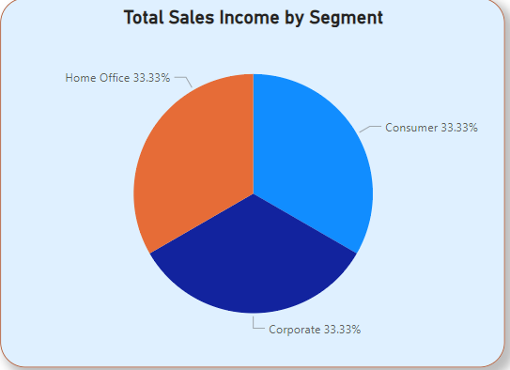

* **Tables:** Provide detailed breakdowns of sales data with additional filters and slicers for interactive exploration.

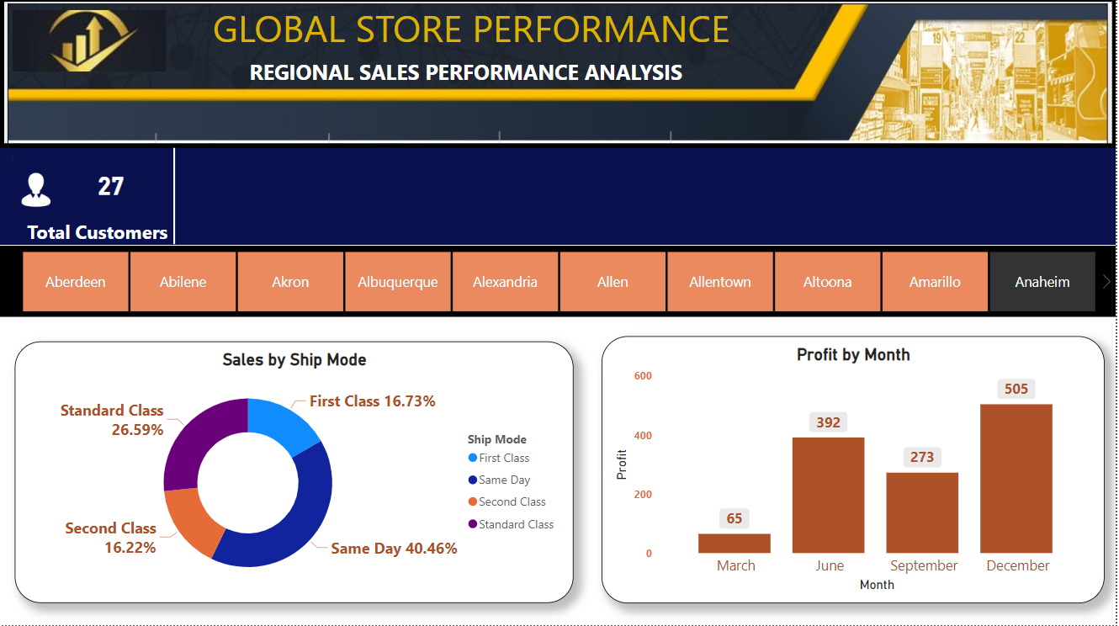

**6. Insights from Charts and Dashboards**

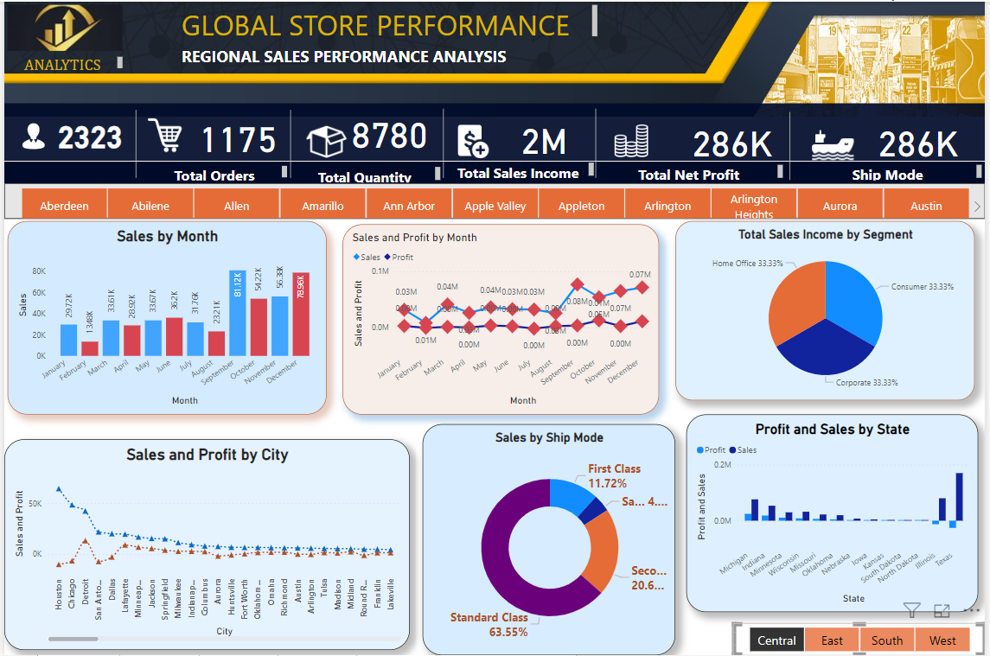

Provide a detailed analysis of the key insights revealed by your visualizations. [Here are some examples based on common sales trends:]

* **Sales Trends:** Identify seasonal patterns, peak sales periods, and potential areas for improvement during low sales periods.
* **Top-Selling Products:** Analysis which products consistently contribute the most to sales and explore factors driving their success.
* **Customer Behaviour:** Understand customer buying habits, identify high-value customer segments, and tailor marketing strategies accordingly.
* **Sales Channels:** Evaluate the effectiveness of different sales channels and optimise resource allocation based on performance.
* **Regional Performance:** Identify geographical areas with strong sales and areas requiring improvement. Consider factors like demographics, marketing reach, and competitor presence.

**7. Conclusion**

The Sales Analysis Power BI report provides valuable insights into sales performance, customer behaviour, and market trends. This information can be leveraged for:

* Develop data-driven sales strategies.
* Improve product development and marketing initiatives.
* Optimise resource allocation for maximum sales growth.
* Identify new sales opportunities and customer segments.
* Make informed decisions to enhance overall business performance.